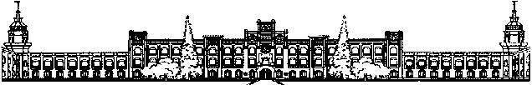

Міністерство освіти і науки України Національний технічний університет України
“Київський політехнічний інститут імені Ігоря Сікорського” Факультет інформатики та обчислювальної техніки

Кафедра інформаційних систем та технологій

Лабораторна робота №6
Технології програмування на C/Embedded
«Communication interfaces (I2C)»

Виконав:
студент групи ІА-33
Мартинюк Ю.Р.

Київ 2025
Тема: Communication interfaces (I2C)
Мета: зрозуміти як працюють I2C інтерфейс та як його налаштувати

Результат виконання роботи:
1) Посилання на додаток:
https://github.com/masonabor/C-Embedded/blob/main/lab6/lab6.zip
2) Посилання на відео роботи:
https://github.com/masonabor/C-Embedded/blob/main/lab6/lab6.mp4
3) Трейс з логічного аналізатора:
https://github.com/masonabor/C-Embedded/blob/main/lab6/lab6.sal

Хід роботи:

Налаштування I2C1

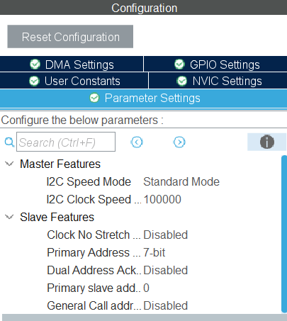

Налаштовуємо конфігурацію на частоту 100000, стандартний режим роботи та 7 бітну адресу
Конфігурація виводів МК

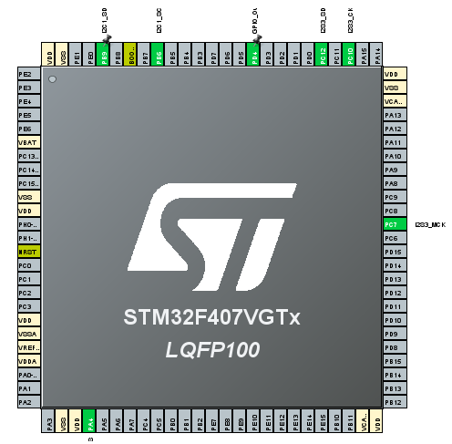

Конфігуруємо виводи I2C1, I2S3

Налаштування I2S3
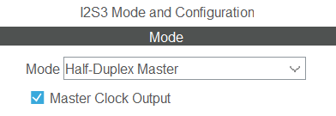
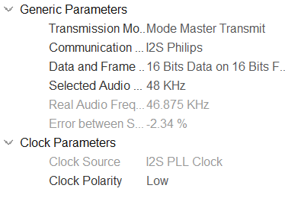

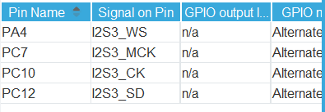

Код main.c

/* USER CODE BEGIN Header */
/**
******************************************************************************
* @file : main.c
* @brief : Main program body
******************************************************************************
* @attention
*
* Copyright (c) 2025 STMicroelectronics.
* All rights reserved.
*
* This software is licensed under terms that can be found in the LICENSE file
* in the root directory of this software component.
* If no LICENSE file comes with this software, it is provided AS-IS.
*
******************************************************************************
*/
/* USER CODE END Header */
/* Includes ------------------------------------------------------------------*/
#include "main.h"

/* Private includes ----------------------------------------------------------*/
/* USER CODE BEGIN Includes */

/* USER CODE END Includes */

/* Private typedef -----------------------------------------------------------*/
/* USER CODE BEGIN PTD */
typedef enum {
NOTE_C4 = 0x00,
NOTE_C5 = 0x10,
NOTE_D5 = 0x20,
NOTE_E5 = 0x30,
NOTE_F5 = 0x40,
NOTE_G5 = 0x50,
NOTE_A5 = 0x60,
NOTE_B5 = 0x70,
NOTE_C6 = 0x80,
NOTE_D6 = 0x90,
NOTE_E6 = 0xA0,
NOTE_F6 = 0xB0,
NOTE_G6 = 0xC0,
NOTE_A6 = 0xD0,
NOTE_B6 = 0xE0,
NOTE_C7 = 0xF0,
NOTE_SILENCE = 0xFF
} soundToneType;
/* USER CODE END PTD */

/* Private define ------------------------------------------------------------*/
/* USER CODE BEGIN PD */
#define CS43L22_I2C_ADDRESS 0x94
#define I2C_TIMEOUT 10
/* USER CODE END PD */

/* Private macro -------------------------------------------------------------*/
/* USER CODE BEGIN PM */

/* USER CODE END PM */

/* Private variables ---------------------------------------------------------*/
I2C_HandleTypeDef hi2c1;

I2S_HandleTypeDef hi2s3;
DMA_HandleTypeDef hdma_spi3_tx;

/* USER CODE BEGIN PV */
int16_t data[100] = {0};
/* USER CODE END PV */

/* Private function prototypes -----------------------------------------------*/
void SystemClock_Config(void);
static void MX_GPIO_Init(void);
static void MX_DMA_Init(void);
static void MX_I2C1_Init(void);
static void MX_I2S3_Init(void);
/* USER CODE BEGIN PFP */

/* USER CODE END PFP */

/* Private user code ---------------------------------------------------------*/
/* USER CODE BEGIN 0 */
void CS43L22_Init(void)
{
HAL_GPIO_WritePin(GPIOD, GPIO_PIN_4, GPIO_PIN_SET);

uint8_t TxBuffer[2];

TxBuffer[0] = 0x0D;
TxBuffer[1] = 0x01;
HAL_I2C_Master_Transmit(&hi2c1, CS43L22_I2C_ADDRESS, (uint8_t*) &TxBuffer, 2, I2C_TIMEOUT);

TxBuffer[0] = 0x00;
TxBuffer[1] = 0x99;
HAL_I2C_Master_Transmit(&hi2c1, CS43L22_I2C_ADDRESS, (uint8_t*) &TxBuffer, 2, I2C_TIMEOUT);

TxBuffer[0] = 0x47;
TxBuffer[1] = 0x80;
HAL_I2C_Master_Transmit(&hi2c1, CS43L22_I2C_ADDRESS, (uint8_t*) &TxBuffer, 2, I2C_TIMEOUT);

TxBuffer[0] = 0x32;
TxBuffer[1] = 0xFF;
HAL_I2C_Master_Transmit(&hi2c1, CS43L22_I2C_ADDRESS, (uint8_t*) &TxBuffer, 2, I2C_TIMEOUT);

TxBuffer[0] = 0x32;
TxBuffer[1] = 0x7F;
HAL_I2C_Master_Transmit(&hi2c1, CS43L22_I2C_ADDRESS, (uint8_t*) &TxBuffer, 2, I2C_TIMEOUT);

TxBuffer[0] = 0x00;
TxBuffer[1] = 0x00;
HAL_I2C_Master_Transmit(&hi2c1, CS43L22_I2C_ADDRESS, (uint8_t*) &TxBuffer, 2, I2C_TIMEOUT);

TxBuffer[0] = 0x04;
TxBuffer[1] = 0xAF;
HAL_I2C_Master_Transmit(&hi2c1, CS43L22_I2C_ADDRESS, (uint8_t*) &TxBuffer, 2, I2C_TIMEOUT);

TxBuffer[0] = 0x0D;
TxBuffer[1] = 0x70;
HAL_I2C_Master_Transmit(&hi2c1, CS43L22_I2C_ADDRESS, (uint8_t*) &TxBuffer, 2, I2C_TIMEOUT);

TxBuffer[0] = 0x05;
TxBuffer[1] = 0x81;
HAL_I2C_Master_Transmit(&hi2c1, CS43L22_I2C_ADDRESS, (uint8_t*) &TxBuffer, 2, I2C_TIMEOUT);

TxBuffer[0] = 0x06;
TxBuffer[1] = 0x07;
HAL_I2C_Master_Transmit(&hi2c1, CS43L22_I2C_ADDRESS, (uint8_t*) &TxBuffer, 2, I2C_TIMEOUT);

TxBuffer[0] = 0x0A;
TxBuffer[1] = 0x00;
HAL_I2C_Master_Transmit(&hi2c1, CS43L22_I2C_ADDRESS, (uint8_t*) &TxBuffer, 2, I2C_TIMEOUT);

TxBuffer[0] = 0x27;
TxBuffer[1] = 0x00;
HAL_I2C_Master_Transmit(&hi2c1, CS43L22_I2C_ADDRESS, (uint8_t*) &TxBuffer, 2, I2C_TIMEOUT);

TxBuffer[0] = 0x1A;
TxBuffer[1] = 0x0A;
HAL_I2C_Master_Transmit(&hi2c1, CS43L22_I2C_ADDRESS, (uint8_t*) &TxBuffer, 2, I2C_TIMEOUT);

TxBuffer[0] = 0x1B;
TxBuffer[1] = 0x0A;
HAL_I2C_Master_Transmit(&hi2c1, CS43L22_I2C_ADDRESS, (uint8_t*) &TxBuffer, 2, I2C_TIMEOUT);

TxBuffer[0] = 0x1F;
TxBuffer[1] = 0x0F;
HAL_I2C_Master_Transmit(&hi2c1, CS43L22_I2C_ADDRESS, (uint8_t*) &TxBuffer, 2, I2C_TIMEOUT);

TxBuffer[0] = 0x02;
TxBuffer[1] = 0x9E;
HAL_I2C_Master_Transmit(&hi2c1, CS43L22_I2C_ADDRESS, (uint8_t*) &TxBuffer, 2, I2C_TIMEOUT);
}

void CS43L22_Beep(soundToneType pitch, uint32_t duration_ms)
{
uint8_t TxBuffer[2];

if (pitch == NOTE_SILENCE) {
HAL_Delay(duration_ms);
return;
}

TxBuffer[0] = 0x1D;
TxBuffer[1] = 0x00;
HAL_I2C_Master_Transmit(&hi2c1, CS43L22_I2C_ADDRESS, (uint8_t*)TxBuffer, 2, I2C_TIMEOUT);

TxBuffer[0] = 0x1C;
TxBuffer[1] = (uint8_t)pitch;
HAL_I2C_Master_Transmit(&hi2c1, CS43L22_I2C_ADDRESS, (uint8_t*)TxBuffer, 2, I2C_TIMEOUT);

TxBuffer[0] = 0x1E;
TxBuffer[1] = 0xC0;
HAL_I2C_Master_Transmit(&hi2c1, CS43L22_I2C_ADDRESS, (uint8_t*)TxBuffer, 2, I2C_TIMEOUT);

HAL_Delay(duration_ms);

TxBuffer[0] = 0x1E;
TxBuffer[1] = 0x00;
HAL_I2C_Master_Transmit(&hi2c1, CS43L22_I2C_ADDRESS, (uint8_t*)TxBuffer, 2, I2C_TIMEOUT);

HAL_Delay(20);
}

void play(void)
{
const uint32_t tempo_multiplier = 1;
const uint32_t t_whole = 2000 / tempo_multiplier;
const uint32_t t_half = 1000 / tempo_multiplier;
const uint32_t t_quart = 500 / tempo_multiplier;

typedef struct {
soundToneType note;
uint32_t duration;
} Note;

const Note melody[] = {
{NOTE_E6, t_quart},

{NOTE_A5, t_quart},
{NOTE_A5, t_quart},
{NOTE_B5, t_quart},
{NOTE_C6, t_quart},

{NOTE_B5, t_quart},
{NOTE_A5, t_quart},
{NOTE_B5, t_quart},

{NOTE_C6, t_quart},
{NOTE_B5, t_quart},
{NOTE_A5, t_quart},

{NOTE_E6, t_half},
{NOTE_SILENCE, t_quart},

{NOTE_E6, t_quart},
{NOTE_A5, t_quart},
{NOTE_A5, t_quart},
{NOTE_B5, t_quart},
{NOTE_C6, t_quart},
{NOTE_B5, t_quart},
{NOTE_A5, t_quart},
{NOTE_B5, t_quart},
{NOTE_C6, t_quart},
{NOTE_B5, t_quart},
{NOTE_A5, t_quart},
{NOTE_E6, t_half},
{NOTE_SILENCE, t_quart},

{NOTE_C6, t_quart},
{NOTE_C6, t_quart},
{NOTE_D6, t_quart},
{NOTE_E6, t_quart},

{NOTE_E6, t_quart},
{NOTE_D6, t_quart},
{NOTE_C6, t_quart},
{NOTE_D6, t_quart},

{NOTE_E6, t_quart},
{NOTE_D6, t_quart},
{NOTE_C6, t_quart},
{NOTE_B5, t_half},
{NOTE_SILENCE, t_quart},

{NOTE_A5, t_quart},
{NOTE_A5, t_quart},
{NOTE_B5, t_quart},
{NOTE_C6, t_quart},
{NOTE_B5, t_quart},
{NOTE_A5, t_quart},
{NOTE_B5, t_quart},
{NOTE_A5, t_half},
{NOTE_SILENCE, t_whole}
};

int totalNotes = sizeof(melody) / sizeof(melody[0]);

for (int i = 0; i < totalNotes; i++) {
CS43L22_Beep(melody[i].note, melody[i].duration);
}
}
/* USER CODE END 0 */

/**
* @brief The application entry point.
* @retval int
*/
int main(void)
{

/* USER CODE BEGIN 1 */

/* USER CODE END 1 */

/* MCU Configuration--------------------------------------------------------*/

/* Reset of all peripherals, Initializes the Flash interface and the Systick. */
HAL_Init();

/* USER CODE BEGIN Init */

/* USER CODE END Init */

/* Configure the system clock */
SystemClock_Config();

/* USER CODE BEGIN SysInit */

/* USER CODE END SysInit */

/* Initialize all configured peripherals */
MX_GPIO_Init();
MX_DMA_Init();
MX_I2C1_Init();
MX_I2S3_Init();

CS43L22_Init();
HAL_I2S_Transmit_DMA(&hi2s3, (uint16_t *)data, 100);

/* USER CODE BEGIN 2 */
for (int i = 0; i < 3; i++) {
play();
}
/* USER CODE END 2 */

/* Infinite loop */
/* USER CODE BEGIN WHILE */
while (1)
{
/* USER CODE END WHILE */

/* USER CODE BEGIN 3 */
}
/* USER CODE END 3 */
}

/**
* @brief System Clock Configuration
* @retval None
*/
void SystemClock_Config(void)
{
RCC_OscInitTypeDef RCC_OscInitStruct = {0};
RCC_ClkInitTypeDef RCC_ClkInitStruct = {0};

/** Macro to configure the PLL multiplication factor
*/
__HAL_RCC_PLL_PLLM_CONFIG(16);

/** Macro to configure the PLL clock source
*/
__HAL_RCC_PLL_PLLSOURCE_CONFIG(RCC_PLLSOURCE_HSI);

/** Configure the main internal regulator output voltage
*/
__HAL_RCC_PWR_CLK_ENABLE();
__HAL_PWR_VOLTAGESCALING_CONFIG(PWR_REGULATOR_VOLTAGE_SCALE1);

/** Initializes the RCC Oscillators according to the specified parameters
* in the RCC_OscInitTypeDef structure.
*/
RCC_OscInitStruct.OscillatorType = RCC_OSCILLATORTYPE_HSI;
RCC_OscInitStruct.HSIState = RCC_HSI_ON;
RCC_OscInitStruct.HSICalibrationValue = RCC_HSICALIBRATION_DEFAULT;
RCC_OscInitStruct.PLL.PLLState = RCC_PLL_NONE;
RCC_OscInitStruct.PLL.PLLSource = RCC_PLLSOURCE_HSI;
if (HAL_RCC_OscConfig(&RCC_OscInitStruct) != HAL_OK)
{
Error_Handler();
}

/** Initializes the CPU, AHB and APB buses clocks
*/
RCC_ClkInitStruct.ClockType = RCC_CLOCKTYPE_HCLK|RCC_CLOCKTYPE_SYSCLK
|RCC_CLOCKTYPE_PCLK1|RCC_CLOCKTYPE_PCLK2;
RCC_ClkInitStruct.SYSCLKSource = RCC_SYSCLKSOURCE_HSI;
RCC_ClkInitStruct.AHBCLKDivider = RCC_SYSCLK_DIV1;
RCC_ClkInitStruct.APB1CLKDivider = RCC_HCLK_DIV1;
RCC_ClkInitStruct.APB2CLKDivider = RCC_HCLK_DIV1;

if (HAL_RCC_ClockConfig(&RCC_ClkInitStruct, FLASH_LATENCY_0) != HAL_OK)
{
Error_Handler();
}
}

/**
* @brief I2C1 Initialization Function
* @param None
* @retval None
*/
static void MX_I2C1_Init(void)
{

/* USER CODE BEGIN I2C1_Init 0 */

/* USER CODE END I2C1_Init 0 */

/* USER CODE BEGIN I2C1_Init 1 */

/* USER CODE END I2C1_Init 1 */
hi2c1.Instance = I2C1;
hi2c1.Init.ClockSpeed = 100000;
hi2c1.Init.DutyCycle = I2C_DUTYCYCLE_2;
hi2c1.Init.OwnAddress1 = 0;
hi2c1.Init.AddressingMode = I2C_ADDRESSINGMODE_7BIT;
hi2c1.Init.DualAddressMode = I2C_DUALADDRESS_DISABLE;
hi2c1.Init.OwnAddress2 = 0;
hi2c1.Init.GeneralCallMode = I2C_GENERALCALL_DISABLE;
hi2c1.Init.NoStretchMode = I2C_NOSTRETCH_DISABLE;
if (HAL_I2C_Init(&hi2c1) != HAL_OK)
{
Error_Handler();
}
/* USER CODE BEGIN I2C1_Init 2 */

/* USER CODE END I2C1_Init 2 */

}

/**
* @brief I2S3 Initialization Function
* @param None
* @retval None
*/
static void MX_I2S3_Init(void)
{

/* USER CODE BEGIN I2S3_Init 0 */

/* USER CODE END I2S3_Init 0 */

/* USER CODE BEGIN I2S3_Init 1 */

/* USER CODE END I2S3_Init 1 */
hi2s3.Instance = SPI3;
hi2s3.Init.Mode = I2S_MODE_MASTER_TX;
hi2s3.Init.Standard = I2S_STANDARD_PHILIPS;
hi2s3.Init.DataFormat = I2S_DATAFORMAT_16B;
hi2s3.Init.MCLKOutput = I2S_MCLKOUTPUT_ENABLE;
hi2s3.Init.AudioFreq = I2S_AUDIOFREQ_48K;
hi2s3.Init.CPOL = I2S_CPOL_LOW;
hi2s3.Init.ClockSource = I2S_CLOCK_PLL;
hi2s3.Init.FullDuplexMode = I2S_FULLDUPLEXMODE_DISABLE;
if (HAL_I2S_Init(&hi2s3) != HAL_OK)
{
Error_Handler();
}
/* USER CODE BEGIN I2S3_Init 2 */

/* USER CODE END I2S3_Init 2 */

}

/**
* Enable DMA controller clock
*/
static void MX_DMA_Init(void)
{

/* DMA controller clock enable */
__HAL_RCC_DMA1_CLK_ENABLE();

/* DMA interrupt init */
/* DMA1_Stream5_IRQn interrupt configuration */
HAL_NVIC_SetPriority(DMA1_Stream5_IRQn, 0, 0);
HAL_NVIC_EnableIRQ(DMA1_Stream5_IRQn);

}

/**
* @brief GPIO Initialization Function
* @param None
* @retval None
*/
static void MX_GPIO_Init(void)
{
GPIO_InitTypeDef GPIO_InitStruct = {0};
/* USER CODE BEGIN MX_GPIO_Init_1 */
/* USER CODE END MX_GPIO_Init_1 */

/* GPIO Ports Clock Enable */
__HAL_RCC_GPIOA_CLK_ENABLE();
__HAL_RCC_GPIOC_CLK_ENABLE();
__HAL_RCC_GPIOD_CLK_ENABLE();
__HAL_RCC_GPIOB_CLK_ENABLE();

/*Configure GPIO pin Output Level */
HAL_GPIO_WritePin(GPIOD, GPIO_PIN_4, GPIO_PIN_RESET);

/*Configure GPIO pin : PD4 */
GPIO_InitStruct.Pin = GPIO_PIN_4;
GPIO_InitStruct.Mode = GPIO_MODE_OUTPUT_PP;
GPIO_InitStruct.Pull = GPIO_NOPULL;
GPIO_InitStruct.Speed = GPIO_SPEED_FREQ_LOW;
HAL_GPIO_Init(GPIOD, &GPIO_InitStruct);

/* USER CODE BEGIN MX_GPIO_Init_2 */
/* USER CODE END MX_GPIO_Init_2 */
}

/* USER CODE BEGIN 4 */

/* USER CODE END 4 */

/**
* @brief This function is executed in case of error occurrence.
* @retval None
*/
void Error_Handler(void)
{
/* USER CODE BEGIN Error_Handler_Debug */
/* User can add his own implementation to report the HAL error return state */
__disable_irq();
while (1)
{
}
/* USER CODE END Error_Handler_Debug */
}

#ifdef USE_FULL_ASSERT
/**
* @brief Reports the name of the source file and the source line number
* where the assert_param error has occurred.
* @param file: pointer to the source file name
* @param line: assert_param error line source number
* @retval None
*/
void assert_failed(uint8_t *file, uint32_t line)
{
/* USER CODE BEGIN 6 */
/* User can add his own implementation to report the file name and line number,
ex: printf("Wrong parameters value: file %s on line %d\r\n", file, line) */
/* USER CODE END 6 */
}
#endif /* USE_FULL_ASSERT */

Висновок: Виконуючи дану роботу, я навчився програмувати обмін даними по шині I2C між STM32 та аудіо-кодеком CS43L22. Було досліджено карту регістрів кодека та реалізовано керування його вбудованим генератором частот. У результаті створено програму, яка відтворює задану мелодію шляхом послідовної передачі команд налаштування частоти та тривалості звучання. Отримані навички дозволяють реалізовувати просту звукову сигналізацію у вбудованих системах з мінімальним використанням обчислювальних ресурсів процесора.

